**Craps Dice Game**

Marrek Pope

CSC 5 – 42520

**Introduction**

Craps is a dice game in which the players make wagers on the outcome of the roll, or a series of rolls, of a pair of dice. Craps developed in the United States from a simplification of the western European game of Hazard. It is a very popular game played in casinos across the country. Some games last 1 roll while others can take multiple rolls to decide if the game results in a “win” or “loss”.

**How the Game Works**

To begin, the Shooter (one of the players) must bet at least the table minimum and takes 2 dice to roll. Other people who are at the table may bet even if they are not rolling the dice. Each round has two phases: Come Out and Point. To start a round, the shooter makes one or more Come Out rolls. A Come Out roll of 2, 3 or 12 (called Craps, the shooter is said to 'crap out') ends the round with players losing their bets. A Come Out roll of 7 or 11 (a Natural) results in a win for the bets. If the shooter does not roll a 2,3,7,11, or 12, the number he rolls is a 4, 5, 6, 8, 9, or 10, which number becomes the Point. The dealer then moves an On button to the point number signifying the second phase of the round. If the shooter rolls the point number, the result is a win for bets. If the shooter rolls a seven (a Seven-out), it results in a loss for the bets and the round ends.

**My Approach to the Game**

Instead of having multiple players at the table, it is just 1 player. The game is driven by a menu, so after asking the player if they want to read the rules of the game the menu opens up. Since part of the fun is gambling, I start players off with $500 to wage as they see fit. I set a minimum wager, like they have in casinos, and also a maximum so they don’t waste all of their money in the first roll. Instead of prompting the user to roll every time, it continues to roll the dice until the outcome of the game is decided. If the user wins, the wager is doubled and if they lose, it is kept by the program. Additionally, there is an option to simulate multiple games of craps, but without the gambling aspect. This allows players to see what the statistics and probabilities of the game are without having to mindlessly press buttons on their keyboard for extended periods of time.

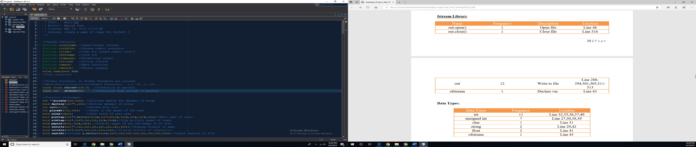**The Logic of it All** (Pseudocode)

Opening comments, bring in all libraries

that we used, set global constants

that we will use for conversions, and

declare function prototypes.

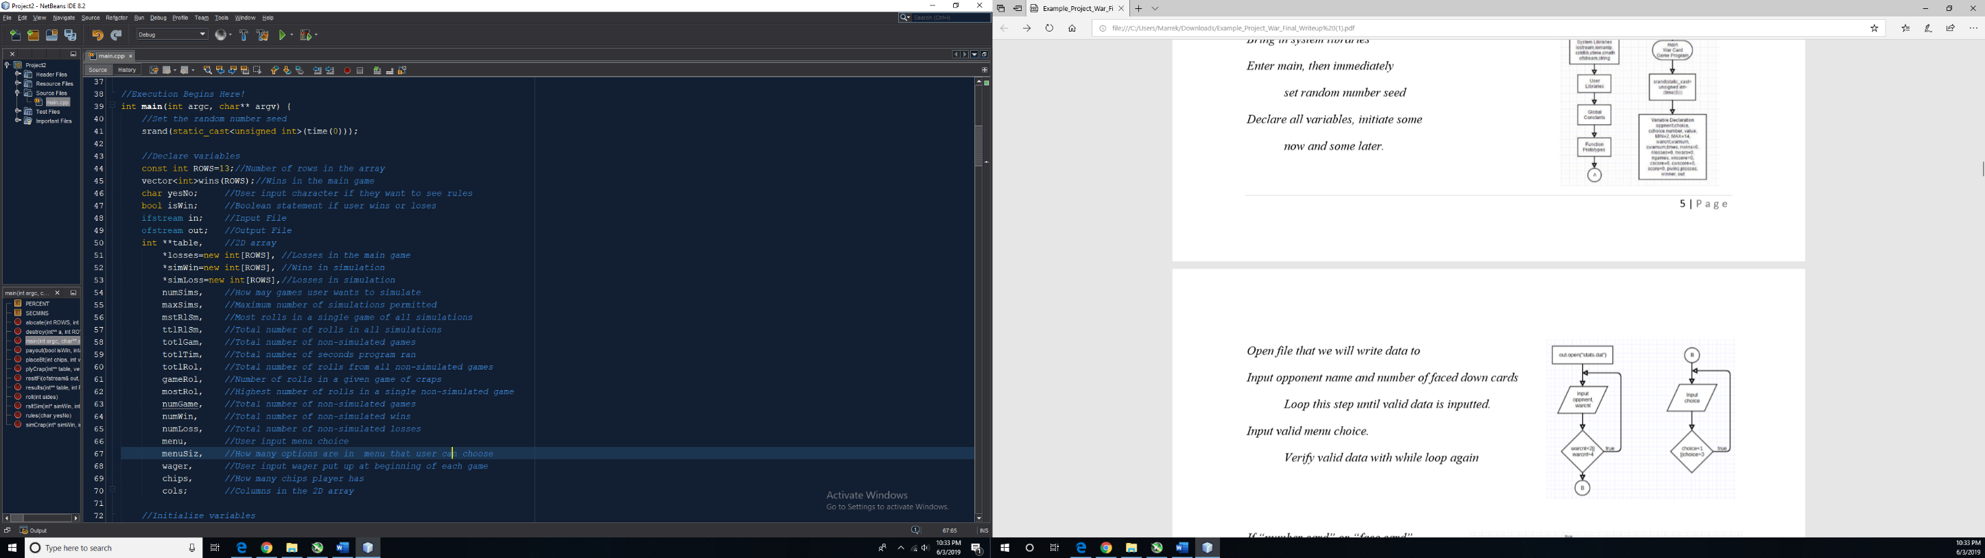

Start execution in main, set random number

seed, and declare all variables and

arrays.

Declare names of the input/output files,

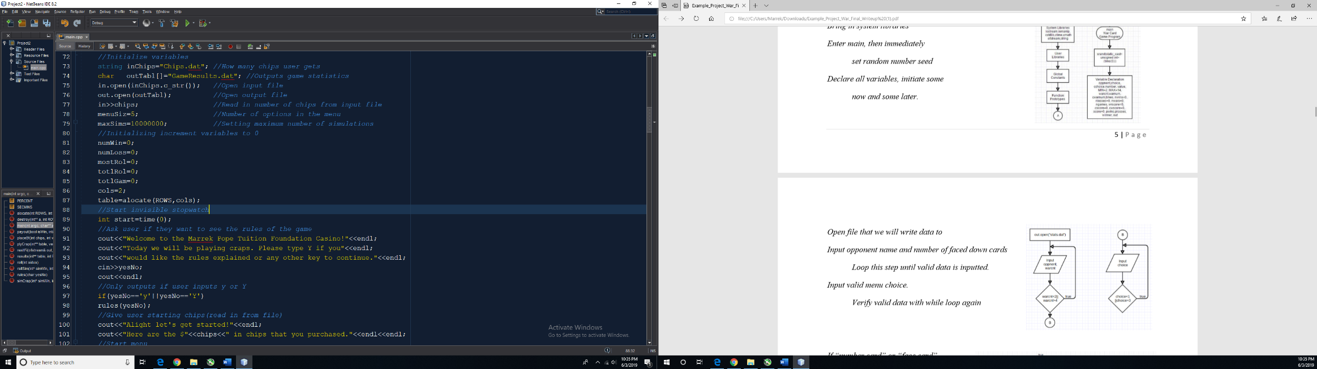open input/output files and read in

the number of chips from input file,

set the value that will terminate the

menu and the maximum number of

simulations.

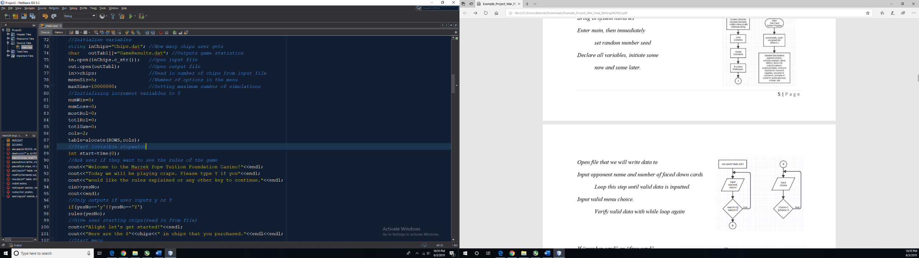Initialize all increment variables to 0, set

the number of columns in 2D array and

allocate memory for the 2D array, and start

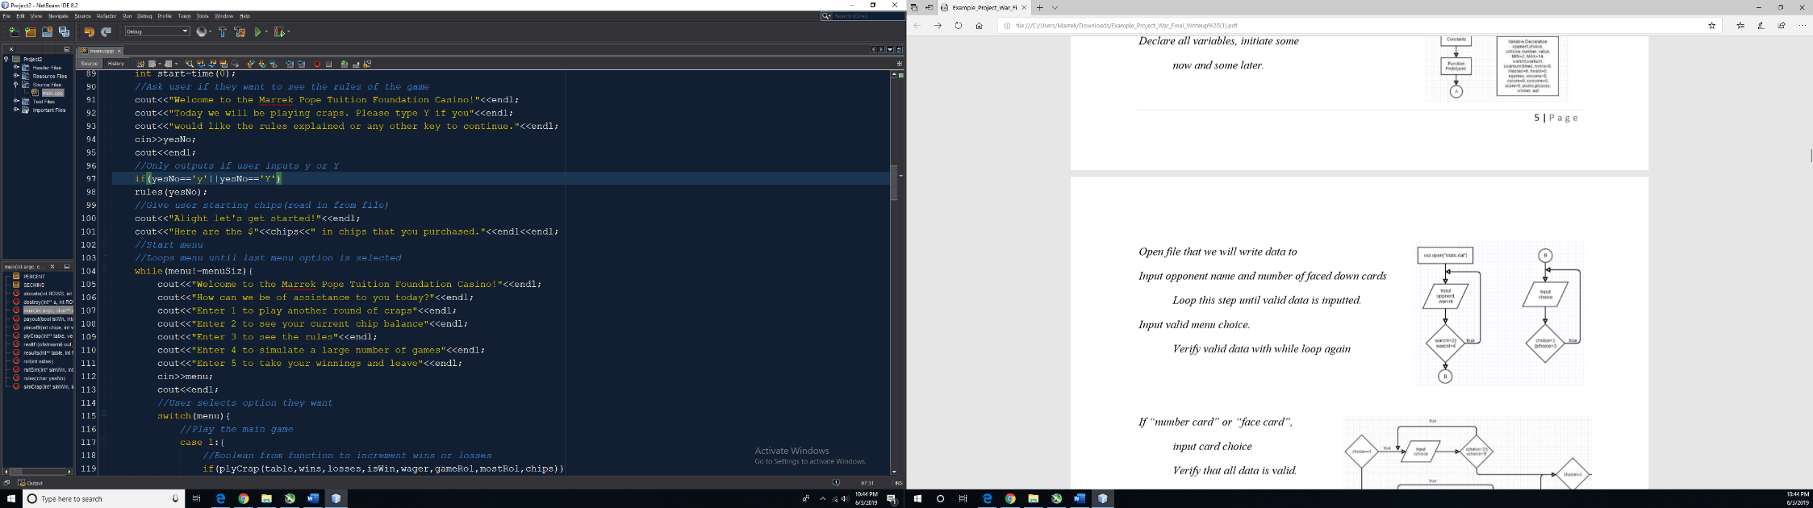background timer.

Welcome user to the game and ask if they want to

read the rules of the game. Give them chips to

gamble in the game. Start the menu and show the

user the options in the program.

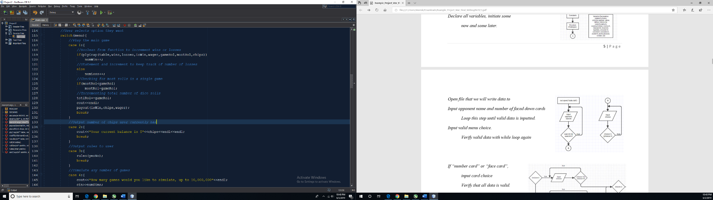Option 1 lets the user play a single game of craps

where they can wager chips on the game’s

outcome. Option 2 shows the user their current

chip balance, and option 3 will show the user the

rules if they did not read them the first time or

forgot.

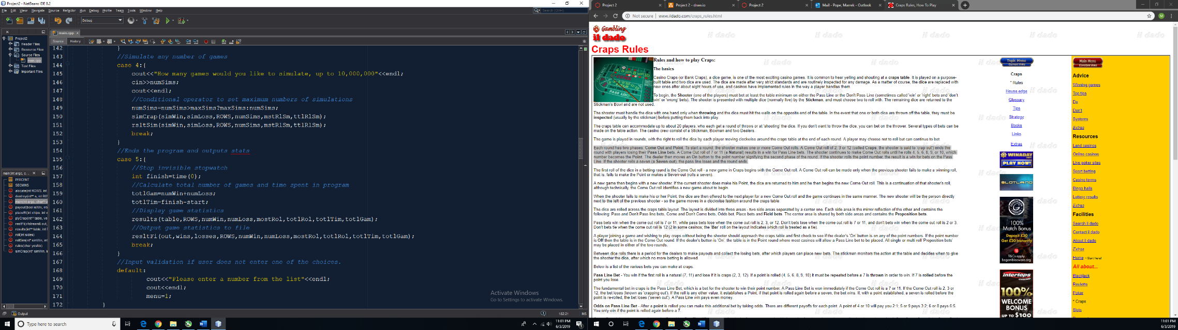Option 4 lets the user simulate multiple games

at once and will display the results of the

simulated games, up to 10,000,000 games.

Option 5 ends the program, displays a table with

the statistics of the single games played, and will

output the statistics to the output file. Any other

number input in the menu will ask the user to

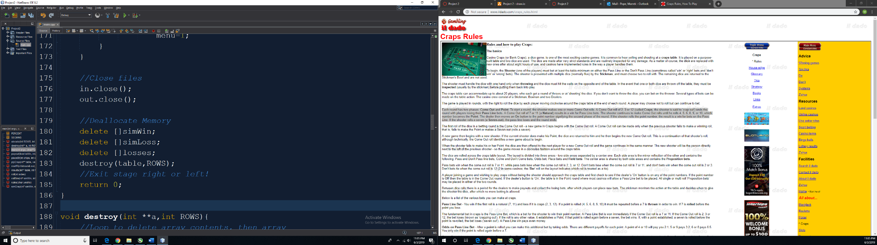input a number in the menu list.

Close input and output files and delete dynamic

memory that was created.

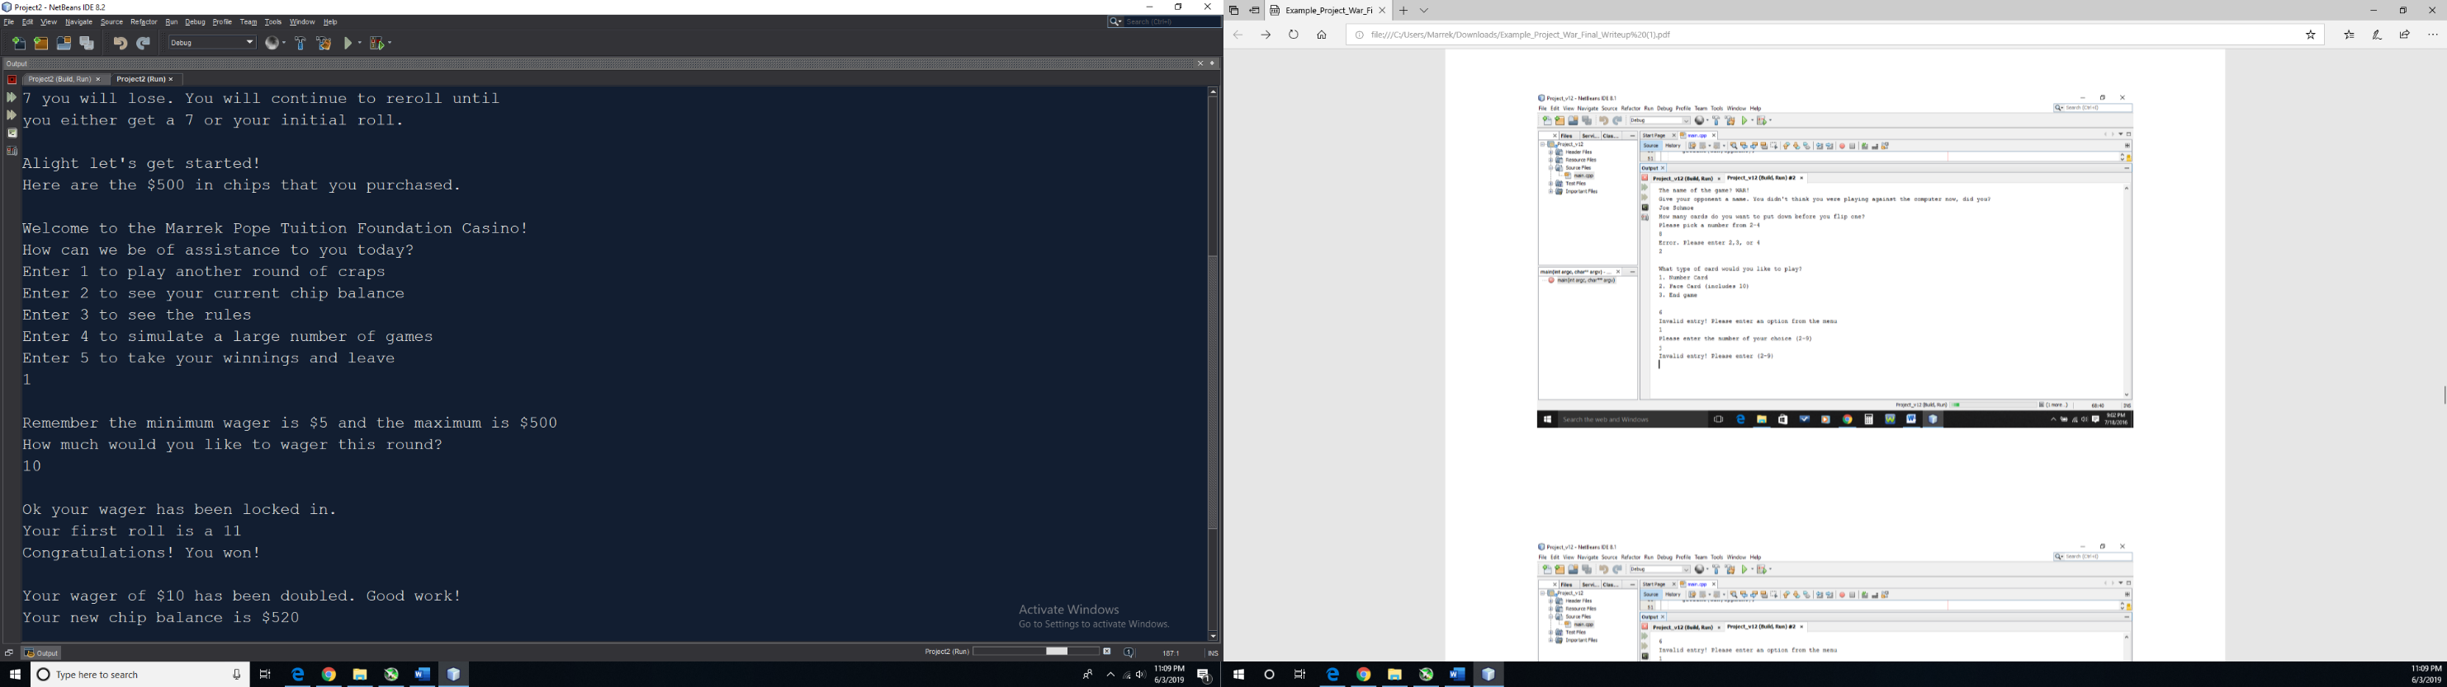**Proof of a Working Project**

